Time limited social distancing measures and the shape of the epidemic curve

M. Woolhouse, A. Morgan and B. van Bunnik, University of Edinburgh (29/02/20)

Results Summary

The plot below compares 6 different scenarios for the *effects* of time-limited social distancing measures implemented for a fixed 12 week period at the same trigger point. SDMs are assumed to have an impact on β. The mean reduction in β over the 12 week period is kept constant. The only difference is how that reduction is distributed over time (red curves).

The epidemic curves (blue) vary considerably: the standard results of a delayed peak and/or a second wave, but only a moderate impact on total number of cases, occur commonly; but there are scenarios that reduce both the peak and the total but do not delay the epidemic.

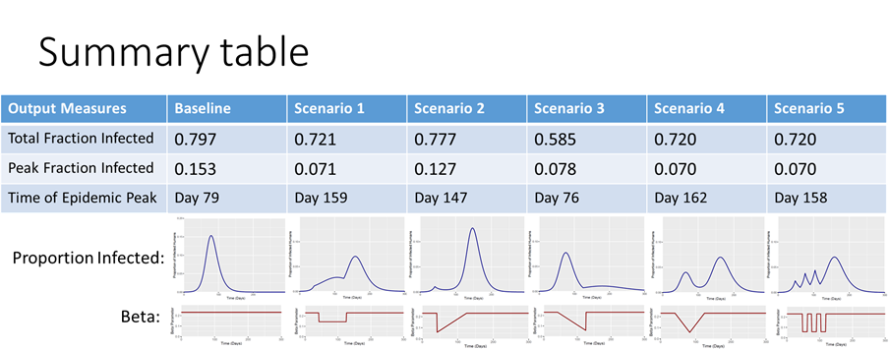

*Figure. Epidemic curves (blue), β(t) curves (red) and summary statistics for baseline case and 5 time=varying, fixed period SDM strategies.*

For this parameter set this behaviour is seen for S3 where reduction is ramping up over time (Figure). Here, the least successful scenario (S2) is the reverse, ramping down. The general pattern is that there is a ‘sweet spot’ between too much, too soon and too little, too late.

Sensitivity analyses so far (but still only partially complete) suggest that the best strategy does vary over parameter space (and with how ‘best’ is defined), particularly with the reduction in β that the SDMs achieve. This is problematic as we have little quantitative information to go on.

Policy Implications

The effects of time varying, fixed period SDMs (as might be implemented in practice) are highly variable and may be extremely difficult to predict. Favourable outcomes – the ‘sweet spot’ – are possible but, in practice, could not be guaranteed in advance.

For some regions of parameter space this analysis supports the idea that SDMs should be introduced in a staggered fashion (but timing must take into account any lags between implementation and an effect on β).

This analysis confirms that a sub-optimal policy (e.g. S2 for the illustrative parameter set) can be doubly damaging: the (potentially huge) social and economic costs of SDMs are incurred but do not prevent a (delayed) epidemic of similar magnitude.

On the other hand, although cases are expected to rise when SDMs cease a damaging second wave does not always ensue.

We emphasize i) that rationale design of a SDM policy must take into account the social and economic costs as well as the epidemiological benefits and ii) that it is vital to have an exit strategy for terminating SDMs.

Technical Details

SIR model implemented in R and C++ independently (code available at https://github.com/bvbunnik/COVID-19.git). R0=2; β = 0.231; doubling time = 6 days; trigger point I(t)=0.01, giving 41 days as the start time of the intervention; SDM duration = 12 weeks; mean reduction in β = 37.5%; temporal pattern in β shown in Figure (red curves).

Raw output files attached.

Rationale

SDMs are intended to be time limited. Multiple SDMs are available and can be implemented independently. (Many) SDMs are socially and economically costly.

We have very little idea of: i) the costs of SDMs; ii) the effect of a given SDM (or combination) on β.

Here, we assume only that costs and effects can be ‘exchanged’ so that by implementing different SDMs at different times we can alter the shape of the β(t)-curve during the period of interest.

We are doing this for a very wide range of mean reductions in β in order to ask whether the comparisons between scenarios (different β(t) curves) are consistent and, if not, what influences this.

Caveats

This is a very simple model and is intended to be illustrative, not predictive of an actual COVID-19 outbreak.

We do not take into account spontaneous SDMs arising from behavioural change and affecting β.

We do not take into account time varying compliance with imposed SDMs.

Ongoing work

Sensitivity analysis for R0, doubling time and mean reduction in β [0 to 100%]. The mean reduction used here is quite high (37.5%) and the maximum reduction gives R0 =0.5. Smaller effects, minimum R0 ≥1, may change the optimum strategy.

Exploration of adjusting trigger point and SDM duration to optimise outcome. We note that the optimal trigger point and duration is expected to be different for different scenarios and need to be identified for each.

Using this approach to inform the design of exit strategies for SDMs.